

Topic test 2
Name: __________________________________

Chapter 6: Time series analysis

- Time allowed: 45 minutes
- CAS calculators may be used.
- Part A: 8 multiple-choice questions (8 marks)
- Part B: 6 short-answer questions (34 marks)
- Part C: 2 analysis questions (20 marks)
Part A
Multiple-choice questions
8 multiple-choice questions
1 mark each: 8 marks
Circle the correct answer.
1 The time series graph shown below displays:
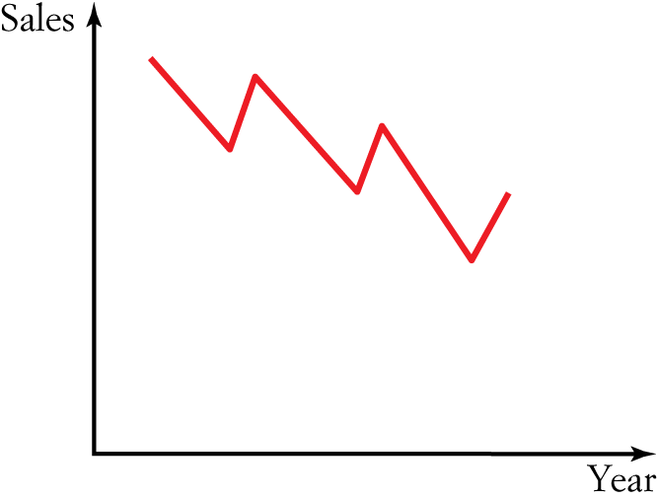
A Random fluctuations only
B Seasonal variation
C Cyclic variation
D A secular positive trend
E A secular negative trend

[1 mark]

2 The time series graph shown below displays:
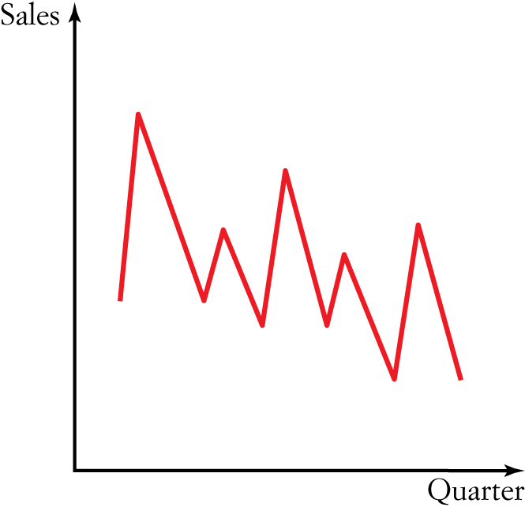
A Random fluctuations only
B Seasonal variation
C Cyclic variation
D A secular positive trend
E A secular negative trend

[1 mark]
3 The seasonal indices (SI) for sales of wetsuits by a surf factory outlet are shown in the table below.
Quarter | 1 | 2 | 3 | 4
SI | 1.23 | 0.97 | 0.66 | 1.14
The actual numbers of wetsuits sold in the second and third quarters, respectively, were 100 and 261.
The seasonally adjusted sales figures are closest to:
A 100, 261
B 103, 395
C 395, 103
D 395, 269
E 269, 395

[1 mark]

4 The seasonal indices (SI) of the sales from a retail outlet are shown in the table below.
Quarter | SI
1 | 0.1
2 | 1.4
3 | 1.3
4 | 1.2
For the first quarter of the year, the deseasonalised sales were a low $100 000. The actual sales figure for the first quarter was:
A $10 000
B $100 000
C $7 142 857
D $7 692 308
E $1 000 000

[1 mark]
5 For the points (2, 1), (4, 2.5), (7, 5.5), (10, 7), the least squares regression line can be expressed as:
A y  1.27t  0.68
B y  0.68t  1.27
C y  –0.78t  0.46
D y  0.78t  0.46
E y  0.75t  0.5

[1 mark]
6 For the following time series situation, which is most likely to apply?
The oxygen levels of a patient with chronic lung failure.
A Positive secular trend
B Negative secular trend
C Seasonal pattern
D Cyclic pattern
E Random pattern

[1 mark]

7 A manufacturer of recipe books has determined the quarterly proportions shown below describing the shop’s quarterly sales projected figures for 3 years.
Year | Q1 | Q2 | Q3 | Q4
2014 | 0.70 | 0.86 | 1.08 | 1.36
2015 | 0.64 | 0.85 | 1.23 | 1.28
2016 | 0.53 | 0.91 | 1.45 | 1.11
The seasonal index for the third quarter is:
A 1.35
B 0.71
C 0.87
D 1.25
E 0.62

[1 mark]
8 A teacher wanted to analyse the number of student absences in his classes. He listed the daily average absentee rates for Year 9 students for each term over a 2-year period and calculated these seasonal indices:
Year | Q1 | Q2 | Q3 | Q4
Seasonalised index | 0.65 | 0.90 | 1.06 | 1.39
If the equation describing the deseasonalised data is:
Absences = 1.7  Term  26
the predicted actual number of absences in the first term of the third year is:
A 41
B 27
C 64
D 28
E 18

[1 mark]

Part B
Short-answer questions
6 short-answer questions
34 marks
Show your working where appropriate.
1 a Use the three-point moving averages method to smooth the following data set.
Plot the resulting graph.
t | 1 | 2 | 3 | 4 | 5 | 6 | 7 | 8 | 9 | 10
y | 3 | 5 | 6 | 10 | 9 | 16 | 12 | 16 | 17 | 20

b What type of trend is this?

[5 marks]
2 The following table shows the interest rates of a personal loan during a volatile period in the economy.
Day t | 1 | 2 | 3 | 4 | 5 | 6 | 7 | 8 | 9 | 10
Rate y (%) | 3.23 | 5.55 | 6.36 | 10.10 | 9.10 | 16.20 | 12.10 | 16.00 | 17.25 | 10.10
a Plot a time series plot and fit a three-median smoothing line to it.

b What type of trend is this?

[5 marks]
3 Draw a time series plot and describe its features for the following data set.
t | 1 | 2 | 3 | 4 | 5 | 6 | 7 | 8
y | 1 | 1 | 6 | 2 | 11 | 4 | 17 | 16

[4 marks]
4 An asthma patient records her peak flow lung capacity, y, during an exacerbation of her disease.
She records this data at the same time each day, t, and constructs the following table.
t | Mon | Tue | Wed | Thu | Fri | Sat | Sun
y | 210 | 220 | 200 | 280 | 300 | 320 | 355
a Draw a time series plot and describe its features.

b Find the least squares regression line and add it to your time series plot.

[6 marks]
5 Staff in a small country hospital tabulate the number of deaths recorded over a period of 3 years as shown in the table below.
Year | Q1 | Q2 | Q3 | Q4
2011 | 3 | 4 | 2 | 5
2012 | 1 | 5 | 2 | 4
2013 | 2 | 2 | 5 | 6
a Create a time series plot using the data given.

b Using technology, find the least squares regression line and add it to your time series plot.
c State the equation of the least squares regression line.

d Use the equation to predict the number of deaths in the small country hospital in the first
quarter of 2014.

[8 marks]

6 A street vendor in New York City is trying to predict his sales of waffles for 2014. The table below shows his sales figures for the years 2008 to 2013.
Year t | 2008 | 2009 | 2010 | 2011 | 2012 | 2013
Sales y  ($1000s) | 10 | 11 | 12 | 10 | 12 | 15
Using a two-point moving median with centring, smooth the data and use it to predict his sales for 2014.

[6 marks]

Part C
Analysis questions
2 analysis questions
20 marks
Show your working where appropriate.
1 The temperature in a greenhouse is measured daily and the results are displayed in the graph below.
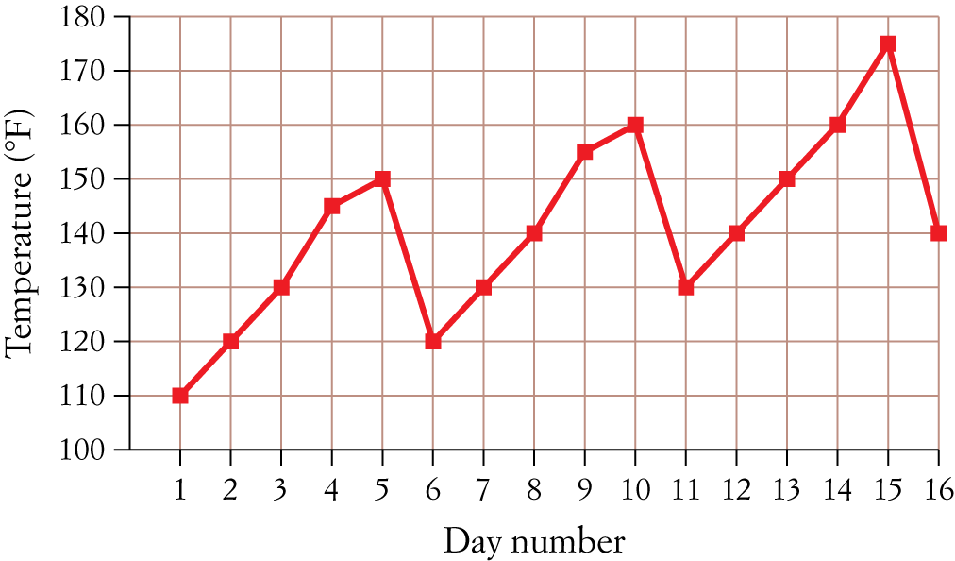
a Smooth the time series data using a three-point moving average.

b Use the smoothed data to predict the temperature for day 17.

c Smooth the time series data using a four-point moving average.

d Describe the trend shown.

[10 marks]
2 The number of aces recorded during a particular timed four-set game at Wimbledon was recorded by an Australian commentator for each of the years from 2010 to 2012.
Year | Aces recorded set 1 | Aces recorded set 2 | Aces recorded set 3 | Aces recorded set 4
2010 | 10 | 70 | 90 | 10
2011 | 10 | 80 | 90 | 40
2012 | 20 | 90 | 100 | 10
a Calculate the seasonal index for each set.

b Deseasonalise the data.

c Plot the original and the deseasonalised time series data.

[10 marks]
[ Total marks: 62]

Answers
Part A – Multiple-choice questions [1 mark each]
1 The time series data over the year shown is moving in an overall negative direction.
∴ E
2 The time series data shown is for a period of 3 months. If we were to divide the graph into three sections, one for each month, we can see that there is a distinct pattern that repeats each month.
∴ B
3 Deseasonalised value  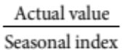
D.V. (2nd quarter)  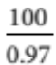  103.09… ≈ 103
D.V. (3rd quarter)  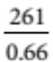  … ≈ 395
∴ B
4 Actual value  Seasonal index  Deseasonalised value
 $100 000  0.1
 $10 000
∴ A
5 CAS required to plot the points and create the least squares regression line, as shown below.
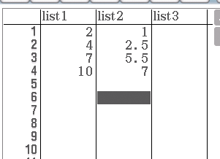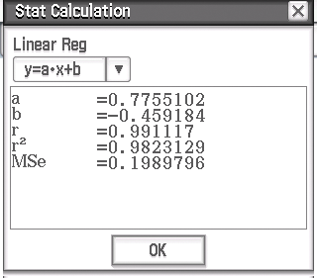
∴ D
6 The lungs of a person with chronic lung failure will gradually deplete and oxygen levels will drop as lung function worsens. Therefore, a graph of oxygen levels will be pointing downwards; i.e. a negative secular trend.
∴ B
7 Seasonal index for third quarter
 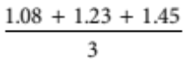
 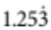
≈ 1.25
∴ D
8 Absences  1.7  Term  26
 1.7  1  26
 27.7
≈ 28
∴ D
Part B – Short-answer questions
1 a
t | 1 | 2 | 3 | 4 | 5 | 6 | 7 | 8 | 9 | 10
y | 3 | 5 | 6 | 10 | 9 | 16 | 12 | 16 | 17 | 20
 |  | 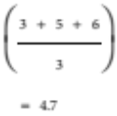 | 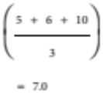 | 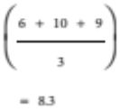 | 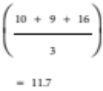 | 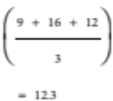 | 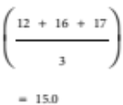 | 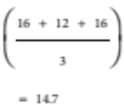 | 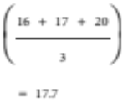
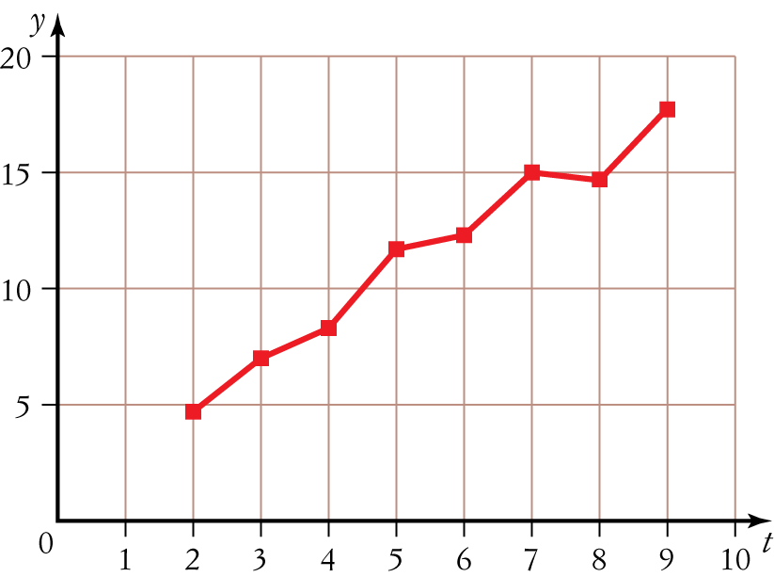
[4 marks]
b Positive secular trend [1 mark]
2 a
t | 1 | 2 | 3 | 4 | 5 | 6 | 7 | 8 | 9 | 10
y ($) | 3.23 | 5.55 | 6.36 | 10.10 | 9.10 | 16.20 | 12.10 | 16.00 | 17.25 | 10.10
 |  | Med (3.23, 5.55, 6.36) | Med (5.55, 6.36, 10.10) | Med (6.36, 10.10, 9.10) | Med (10.10, 9.10, 16.20) | Med (9.10, 16.20, 12.10) | Med (16.20, 12.10, 16.00) | Med (12.10, 16.00, 17.25) | Med (16.00, 17.25, 10.10)
 |  |  5.55 |  6.36 |  9.10 |  10.10 |  12.10 |  16.00 |  16.00 |  16.00

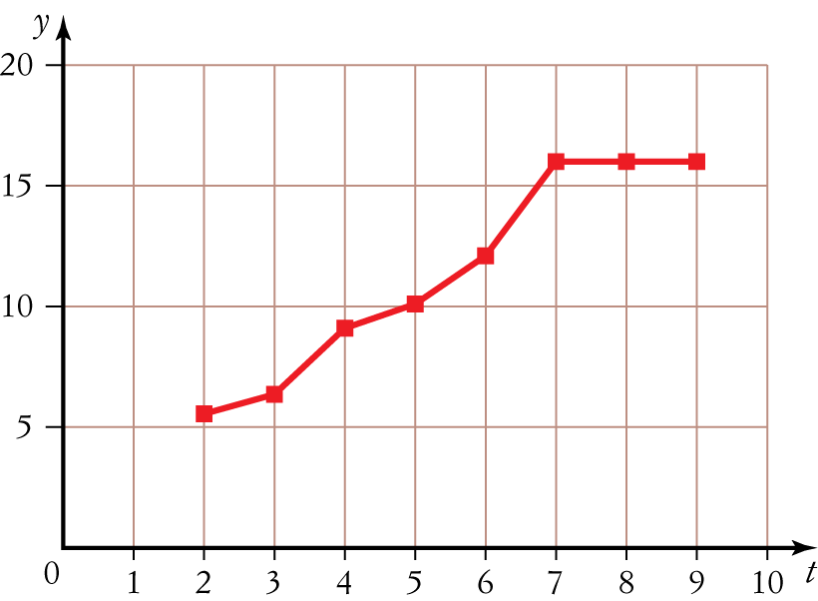
[4 marks]
b Positive secular trend [1 mark]
3 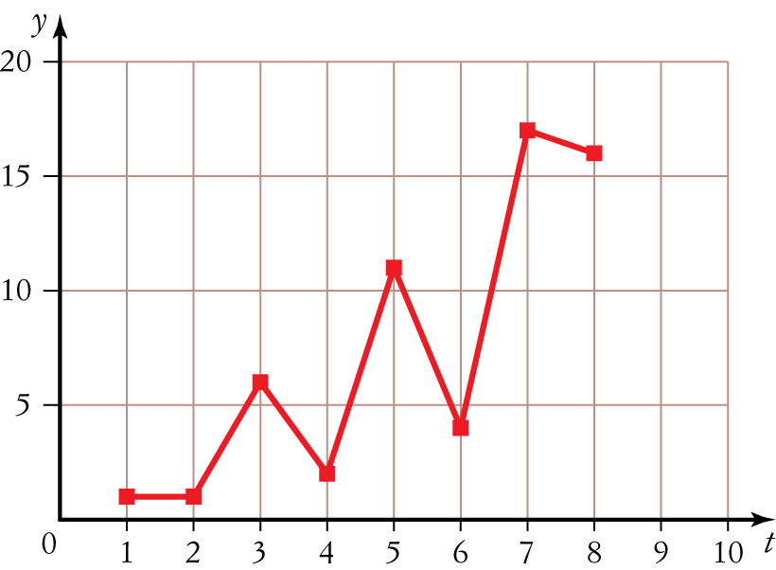
[3 marks]
Cyclic trend peaking approximately every second point [1 mark]
4
t | 1 | 2 | 3 | 4 | 5 | 6 | 7
y | 210 | 220 | 200 | 280 | 300 | 320 | 355

a 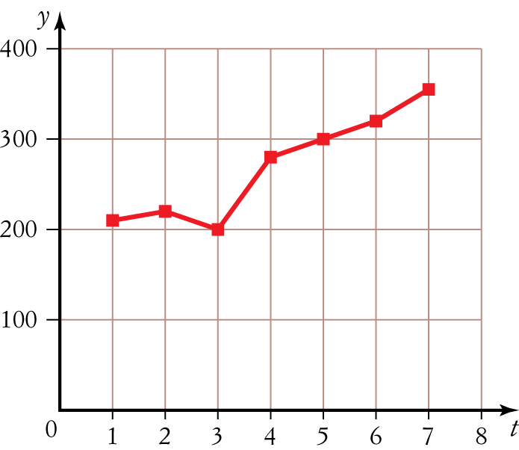
Plot shows patient’s peak flow is improving over the 7 days. [3 marks]
b Equation of least squares regression line is y  26.25t  164.29. [1 mark]
Addition to the time series plot of the least squares regression line is shown below
[2 marks]
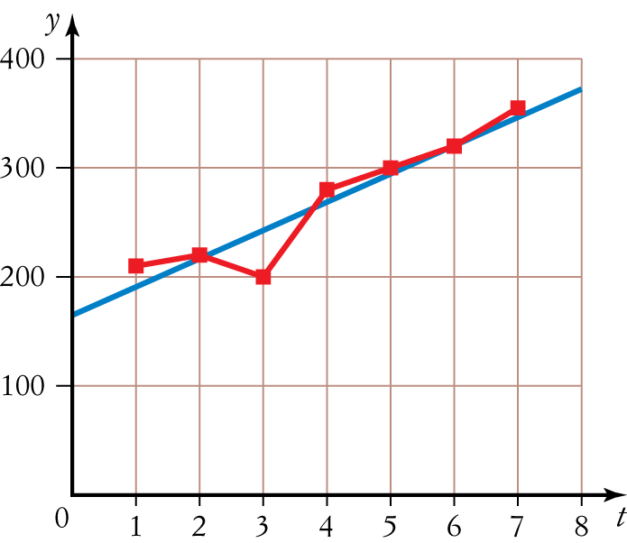

5 a 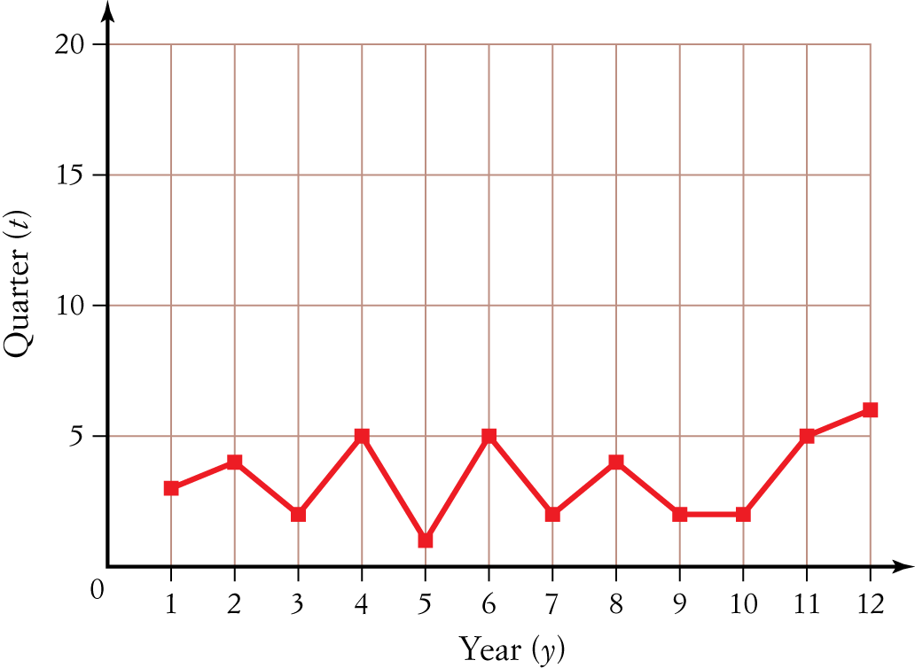
[3 marks]
b 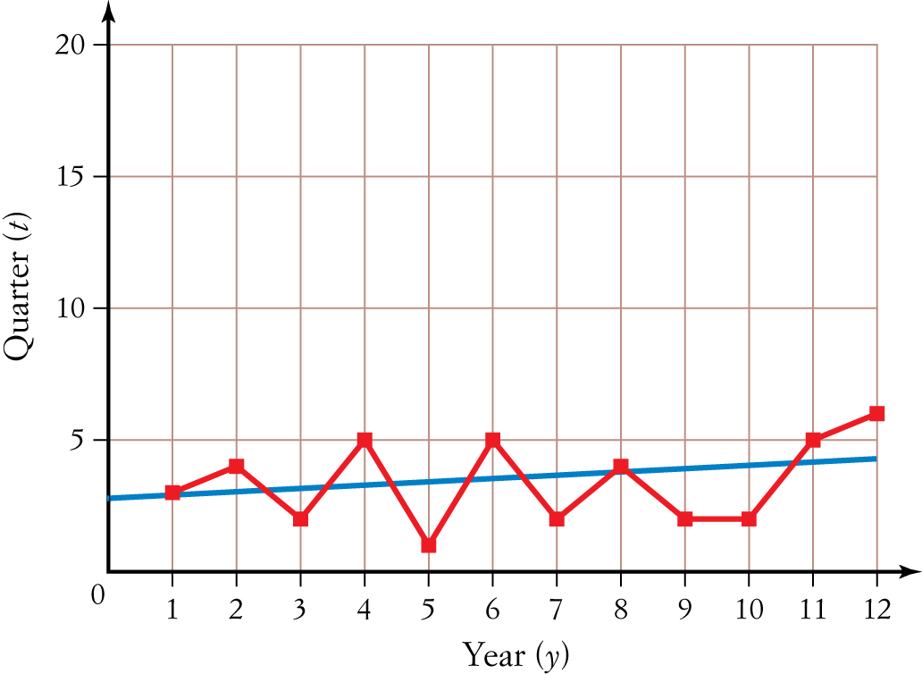
[2 marks]
c y  0.12t  2.67 [1 mark]
d At t  13, y  0.12  13  2.67  4.23
Round down to 4 deaths.
Predicted number of deaths for the first quarter of 2014 is four. [2 marks]

6
Year t/Sales y ($1000s) |  | Two-point moving median | Two-point moving median with centring
1 | 10
 |  | Med (10,11)  10.5
2 | 11 |  | 11
 |  | Med (11,12)  11.5
3 | 12 |  | 11.25
 |  | Med (12,10)  11
4 | 10 |  | 11
 |  | Med (10,12)  11
5 | 12 |  | 12.25
 |  | Med (12,15)  13.5
6 | 15

[3 marks]
Trend line: y = 0.35t + 10.15 [1 marks]
Sales for 2014: t = 7
y = 2.4 + 10.15
= 12.6
∴ $12 600 in sales predicted for 2014 [2 marks]
Part C – Analysis questions
1 a
Day t | Temperature y (8F) | Three-point moving average
1 | 110
2 | 120 | (110 + 120 + 130)/3  120
3 | 130 | (120 + 130 + 145)/3  131.67
4 | 145 | (130 + 145 + 150)/3  141.67
5 | 150 | (145 + 150 + 120)/3  138.33
6 | 120 | (150 + 120 + 130)/3  133.33
7 | 130 | (120 + 130 + 140)/3  130
8 | 140 | (130 + 140 + 155)/3  141.67
9 | 155 | (140 + 155 + 160)/3  151.67
10 | 160 | (155 + 160 + 130)/3  148.33
11 | 130 | (160 + 130 + 140)/3  143.33
12 | 140 | (130 + 140 + 150)/3  140
13 | 150 | (140 + 150 + 160)/3  150
14 | 160 | (150 + 160 + 175)/3  161.67
15 | 175 | (160 + 175 + 140)/3  158.33
16 | 140

[3 marks]
b Trend line: y = 122.9 + 2.26t
When t = 17, y = 161.
Therefore, the predicted temperature for day 17 is 161°F.
[2 marks]
c Smoothing the time series data using a four-point moving average gives the following.
Day t | Temperature y | Four-point moving average | Four-point moving average with centring
1 | 110
2 | 120
 |  | (110 + 120 + 130 + 145)/4 = 126.25
3 | 130 |  | 131.25
 |  | (120 + 130 + 145 + 150)/4 = 136.25
4 | 145 |  | 136.25
 |  | (130 + 145 + 150 + 120)/4 = 136.25
5 | 150 |  | 136.25
 |  | (145 + 150 + 120 + 130)/4 = 136.25
6 | 120 |  | 135.625
 |  | (150 + 120 + 130 + 140)/4 = 135
7 | 130 |  | 135.625
 |  | (120 + 130 + 140 + 155)/4 = 136.25
8 | 140 |  | 141.25
 |  | (130 + 140 + 155 + 160)/4 = 146.25
9 | 155 |  | 146.25
 |  | (140 + 155 + 160 + 130)/4 = 146.25
10 | 160 |  | 146.25
 |  | (155 + 160 + 130 + 140)/4 = 146.25
11 | 130 |  | 145.625
 |  | (160 + 130 + 140 + 150)/4 = 145
12 | 140 |  | 145
 |  | (130 + 140 + 150 + 160)/4 = 145
13 | 150 |  | 150.625
 |  | (140 + 150 + 160 + 175)/4 = 156.25
14 | 160 |  | 156.25
 |  | (150 + 160 + 175 + 140)/4 = 156.25
15 | 175
16 | 140
[4 marks]
d Trend is best described as seasonal. [1 mark]
Year | Aces recorded set 1 | Aces recorded set 2 | Aces recorded set 3 | Aces recorded set 4 | Yearly average
2010 | 10/45 | 70/45 | 90/45 | 10/45 | 180/4 = 45
2011 | 10/55 | 80/55 | 90/55 | 40/55 | 220/4 = 55
2012 | 20/55 | 90/55 | 100/55 | 10/55 | 220/4 = 55
SI | 0.26 | 1.55 | 1.82 | 0.38
SI | 0.26 | 1.55 | 1.82 | 0.38
2 a
Year | Aces recorded set 1 | Aces recorded set 2 | Aces recorded set 3 | Aces recorded set 4
2010 | 10/0.26 = 38.46 | 70/1.55 = 45.16 | 90/1.82 = 49.45 | 10/0.38 = 26.32
2011 | 10/0.26 = 38.46 | 80/1.55 = 51.61 | 90/1.82 = 49.45 | 40/0.38 = 105.26
2012 | 20/0.26 = 76.92 | 90/1.55 = 58.06 | 100/1.82 = 54.95 | 10/0.38 = 26.32

[4 marks]
b Deseasonalised data

Year | Aces recorded set 1 | Aces recorded set 2 | Aces recorded set 3 | Aces recorded set 4
2010 | 38.46 | 45.16 | 49.45 | 26.32
2011 | 38.46 | 51.61 | 49.45 | 105.26
2012 | 76.92 | 58.06 | 54.95 | 26.32
[4 marks]
c Original time series data
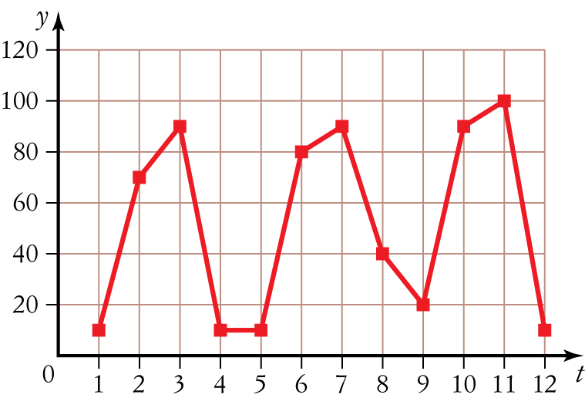
Deseasonalised time series data
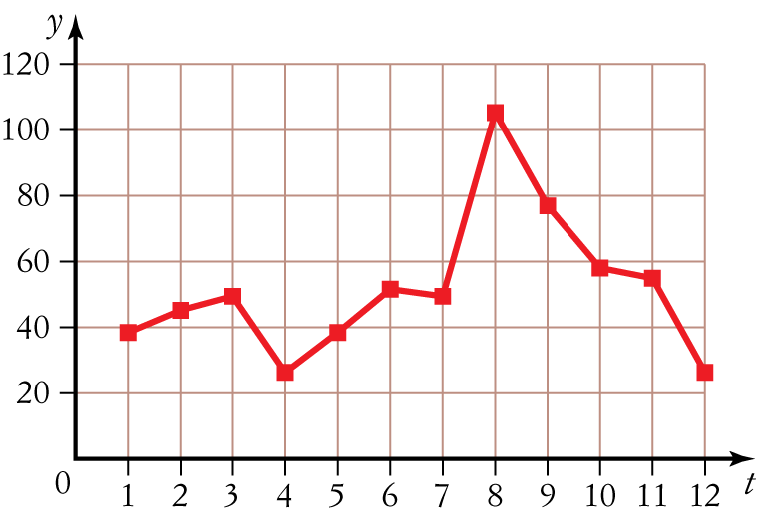
[2 marks]

